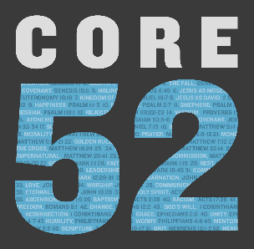

**Week 1 Discussion Guide**

*In the Beginning, God created the heavens and the earth.* – Genesis 1:1

**Intro Questions:**

* Have you ever thought about all three members of the trinity playing a role in creation before? What do you think about that?
* How does our human drive to create mirror God’s creative nature?

**Key Passages:**

* Genesis 1:1 (Core Passage)
* Genesis 1-2

Did anything strike you differently when reading these chapters in light of this week’s essay?

* John 1:1, Ephesians 2:10, Colossians 1:15-16

What came to mind as you meditated on these verses this week?

Did God challenge you through anything in these verses?

**Group Discussion:**

* What do you enjoy doing to connect with creation?
* What is the consequence of ignoring God, the Spirit, and or Jesus as Creator? How have you seen this play out?
* Share something you created and how you feel about it.
* What explanations of creation or origins of the earth and humanity have you heard through education, conversation, and culture? How does this align with what was taught this week?
* Some people say they worship better in creation than in church, why then do we meet in a church? Explore Hebrews 10:25 and share your thoughts on how this relates to the question.
* What is the difference between a church building and the Church?
* Read 1 Thessalonians 5:19 in the NLT (New Living Translation) and explore the context of the verse for additional insight. What does it mean to stifle the Holy Spirit? How do you actually do that? What are the consequences of doing so?
* There is a difference between the seen and the unseen things we have created. Why do we feel a sense of satisfaction in the seen and struggle in the unseen?
* Relationships are an unseen creation. Share an example of a positive relationship and why you are thankful for them.
* Should we hold greater value in our seen or unseen creations?

**Action Steps / Application**

Share what you will do to carry out the following action steps for this week. By understanding that Eden was all about relationship with God, then restoring Eden is about restoring relationship. Use this to frame your response.

* Based on the essay question from Page 11, what was your one small thing you could do today to “help restore Eden”?
* Do you believe it’s possible to do at least one thing to help restore Eden every day? Why or why not?
* Here is your challenge: Pick one of the following to complete today: write a note of encouragement, send three texts of gratefulness, send a note of apology, or reach out to someone who is alienated.