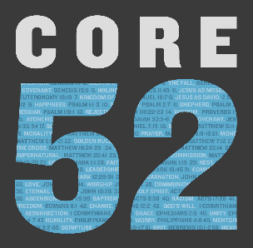

**Week 4 Discussion Guide**

*[Abram] believed the Lord, and he counted it to him as righteous. – Genesis 15:6*

**Intro Questions:**

* Have you ever given much thought to Abraham being the “father” of so many people and faith-systems? What did you think?
* On page 31, the essay challenged us to rethink the word faith by replacing it with faithful. Did anyone give this a try? What was your experience?

**Key Passages:**

* Genesis 15:6 (Core Passage)
* Genesis 21:1-22:18

How many different ways did God prove his faithfulness in these chapters?

* Genesis 12:1-9, Romans 4, Galatians 3:6

What came to mind as you meditated on these verses this week?

Did God challenge you through anything in these verses?

**Group Discussion:**

* How do you define faith?
* Read Romans 10:9 and talk about the necessary aspects of a saving faith. How would you explain saving faith in your own words?
* Read Romans 10:17 & Hebrews 11:1. If faith is a gift from God then what credit can we take in believing and following Christ?
* How is Abraham a model of faith? What did he do to demonstrate his faith?
* Abraham's faith was constantly tested, and many times, he failed. Yet he is upheld as a hero of faith. Have you seen a pattern of success and failure in your own faith journey? How can this build our faith? The faith of others?
* There are times we completely trust God and times we take matters into our own hands? How does this speak to the patience and understanding of God?
* What is the difference between faith and fidelity?
* Is the idea of a covenant new to you? Does it change how you look at your relationship with Christ? Does it change how you view your connection to the church?
* Can you give an example of a modern covenant?
* Read the following passages and discuss how Jesus ultimately fulfilled each of the previous Biblical covenants: Genesis 3:15; 1 Peter 3:21; Genesis 22:12-14; Matthew 22:44; Matthew 26:27–28.
* Share an area of your life where you feel like God would want you to increase your faith—not how much you believe, but your fidelity to obey.

**Action Steps / Application**

* On Page 32, you were challenged to read Romans 3:21-31, replace the word faith with faithfulness.
* Who completed that challenge this week? What stood out to you as you did that?
* Do you think this practice could help you as a continual habit when reading the Bible? Why or why not?
* We were designed for community, - to bear one another’s burdens. Ask someone to pray for an area of your life that you struggle to believe will change.