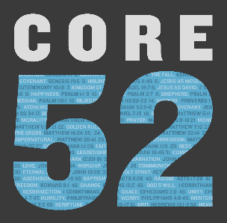

**Week 5 Discussion Guide**

*I am the Lord who brought you up out of the land of Egypt to be your God. You shall therefore be holy, for I am holy. – Leviticus 11:45*

**Intro Questions:**

* Prior to this week’s essay, what came to mind when you thought of the word holiness?
* One page 34, the essay emphatically reminds us: “You are holy not because of your performance but because of God’s proclamation.” What are the practical implications of that statement for your life?

**Key Passages:**

* Leviticus 11:45 (Core Passage)
* 2 Samuel 11, Psalm 51

What does David’s moral failure (2 Samuel 11) and his response to God (Psalm 51) reveal to us about personal holiness?

* Exodus 19:6, 2 Corinthians 7:1, 1 Peter 2:9

What came to mind as you meditated on these verses this week

Did God challenge you through anything in these verses?

**Group Discussion:**

* How does Mark Moore’s explanation of holiness change or affirm the way you have understood it?
* How is holiness different than perfection? Refer to 1 Peter 1:13-16 & Matthew 5:48
* How is relationship the key to holiness? If relationship is so important, then why did God give us rules? What do the rules do for us, for others, and for God?
* Is there an aspect of performance involved in holiness or does God choose how holy we become in life?
* How do you grow in holiness?
* How do you make your desires line up with what God desires for you?
* In your experience, why does someone’s attempt to be holy by behavior modification lead to hypocrisy, secrets, guilt, judgment, and pride? (Answer one topic at a time.)
* Are there things you assume pastors, missionaries, or professionals in ministry can do for God that you are not as capable of accomplishing?
* Is there anything in your life you’ve kept secret that could be holding you back from pursuing holiness?
* Is there anything you refuse to share with someone closest to you (like the toothbrush example on page 34)?
* Do you have an area of life where your actions don’t line up with what you know God expects of you?

**Action Steps / Application**

* On page 38, you were challenged to seek out a place to serve voluntarily so you can tap into God’s purpose for you, have you taken steps to complete this challenge this week?
* Spend five minutes praying to God to reveal where you are struggling to live by God’s moral standards and write them down. After that, spend 5-10 minutes praying that God will give you the strength to overcome.